**Insert PgAdmin4**

-- Database: postgres

CREATE TABLE Persons (

MatricNo int NOT NULL,

StudentName varchar(255),

Semester varchar(255),

Session varchar(255),

Organization varchar(255),

PRIMARY KEY (MatricNo)

);

INSERT INTO Persons(MatricNo, StudentName, Semester, Session, Organization)

VALUES(253933,'Ramesh',7,'2018/2019','SOC');

INSERT INTO Persons(MatricNo, StudentName, Semester, Session, Organization)

VALUES(253055,'Khilan',7,'2018/2019','COB');

INSERT INTO Persons(MatricNo, StudentName, Semester, Session, Organization)

VALUES(253982,'Kavshik',7,'2018/2019','SOC');

SELECT * FROM Persons;

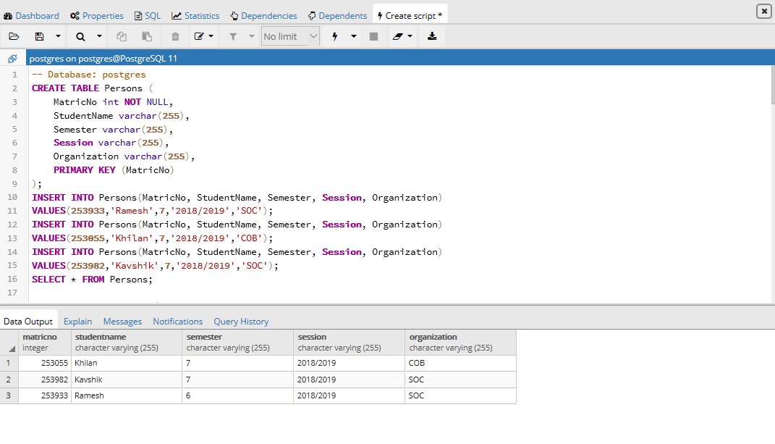

CREATE TABLE Lecturer (

LecturerName varchar(255),

Date varchar(255),

MatricNo int NOT NULL,

FOREIGN KEY(MatricNo) REFERENCES Persons(MatricNo)

);

INSERT INTO Lecturer(LecturerName, Date, MatricNo)

VALUES('Selina','15/11/2018', 253933);

INSERT INTO Lecturer(LecturerName, Date, MatricNo)

VALUES('Siti','16/11/2018', 253055);

INSERT INTO Lecturer(LecturerName, Date, MatricNo)

VALUES('Farah','18/11/2018', 253982);

SELECT * FROM Lecturer;

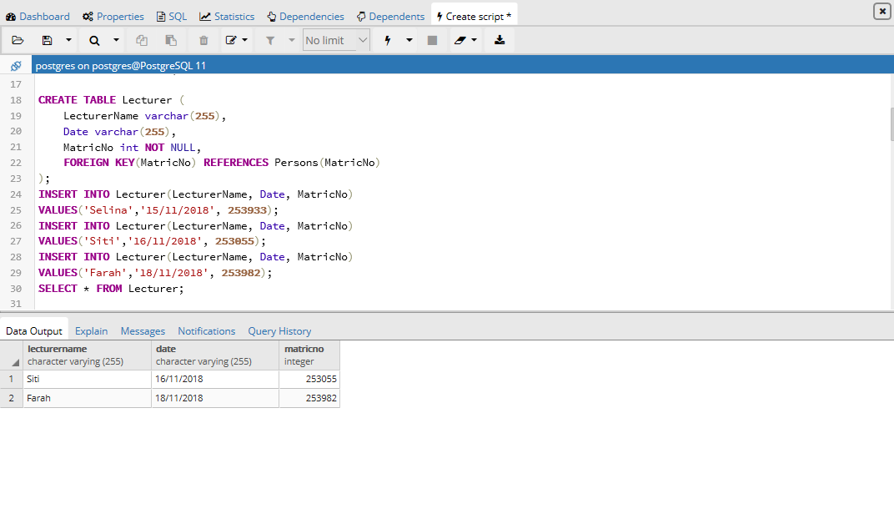

CREATE TABLE SectionA (

SectionA_ID int NOT NULL,

Verbal_Communication float,

Partical_Project_Demo float,

TotalA float,

MatricNo int NOT NULL,

PRIMARY KEY(SectionA_ID),

FOREIGN KEY(MatricNo) REFERENCES Persons(MatricNo)

);

INSERT INTO SectionA

VALUES(1001,5,5,10,253933);

INSERT INTO SectionA

VALUES(1002,4.5,4.5,9,253055);

INSERT INTO SectionA

VALUES(1003,4,6,10,253982);

SELECT * FROM SectionA;

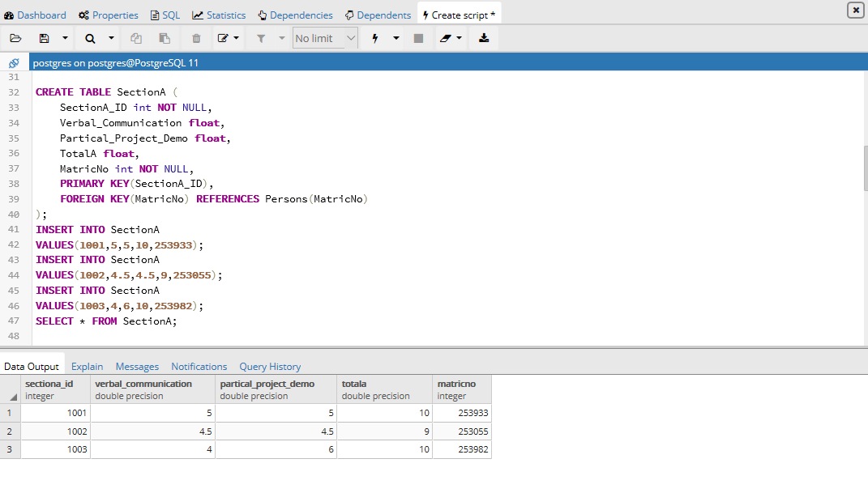

CREATE TABLE SectionB (

SectionB_ID int NOT NULL,

Knowledge float,

Problem_Solving float,

Social_Skill_Responsibility float,

Values_Attitudes_Professionalism float,

Lifelong_Learning float,

TotalB float,

MatricNo int NOT NULL,

PRIMARY KEY(SectionB_ID),

FOREIGN KEY(MatricNo) REFERENCES Persons(MatricNo)

);

INSERT INTO SectionB

VALUES(2001,2.5,2.5,2.5,2.5,2.5,12.5,253933);

INSERT INTO SectionB

VALUES(2002,1.5,1.5,1.5,1.5,1.5,7.5,253055);

INSERT INTO SectionB

VALUES(2003,2,2,2,2,2,10,253982);

SELECT * FROM SectionB;

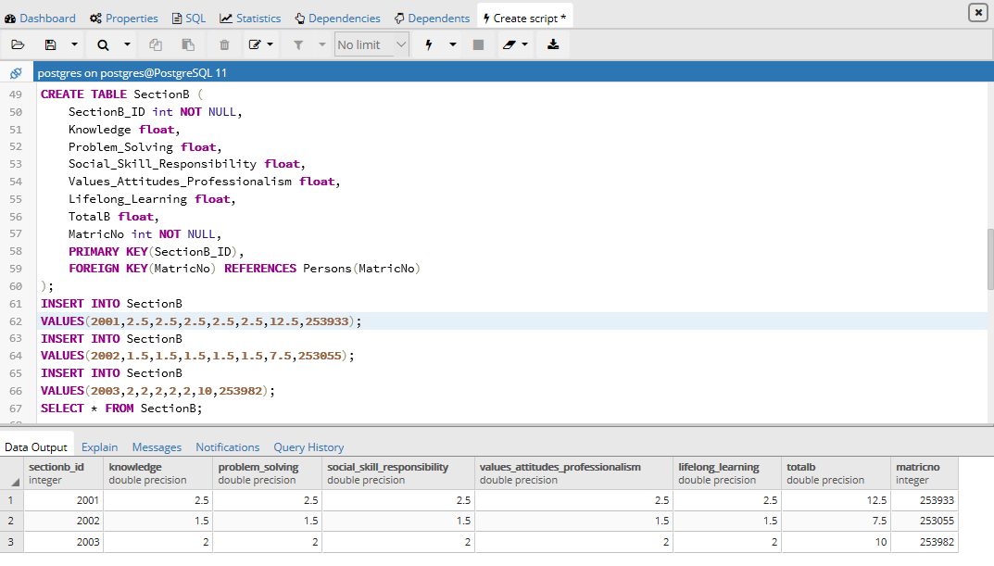

CREATE TABLE SectionC (

SectionC_ID int NOT NULL,

Proposal float,

Report_Draft float,

Final_Report float,

Log_Book float,

TotalC float,

MatricNo int NOT NULL,

PRIMARY KEY(SectionC_ID),

FOREIGN KEY(MatricNo) REFERENCES Persons(MatricNo)

);

INSERT INTO SectionC

VALUES(3001,3,3,3,3,12,253933);

INSERT INTO SectionC

VALUES(3002,2.5,2.5,2.5,2.5,10.0,253055);

INSERT INTO SectionC

VALUES(3003,1,2,3,4,10,253982);

SELECT * FROM SectionC;

P;

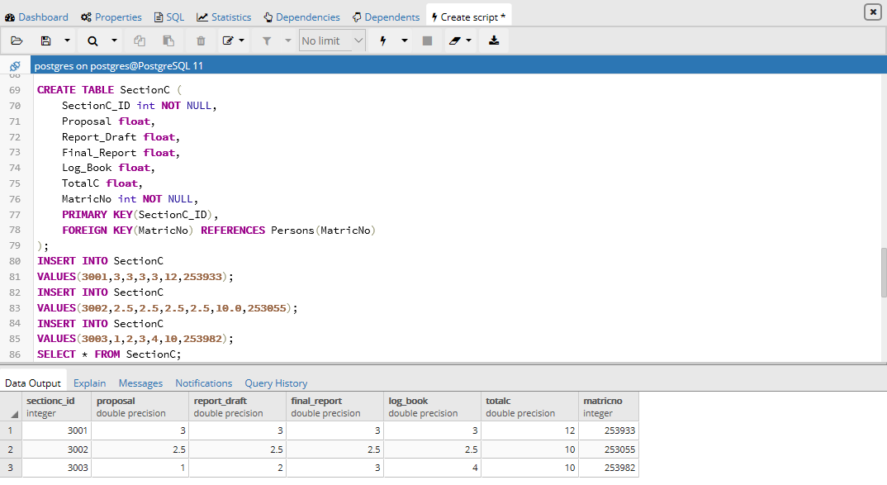

CREATE TABLE EvaluationForm (

EvaluationForm_ID varchar (255) NOT NULL,

GrandTotal float,

MatricNo int NOT NULL,

PRIMARY KEY(EvaluationForm_ID),

FOREIGN KEY(MatricNo) REFERENCES Persons(MatricNo)

);

INSERT INTO EvaluationForm

VALUES('A001',33.5,253933);

INSERT INTO EvaluationForm

VALUES('A002',27.5,253055);

INSERT INTO EvaluationForm

VALUES('A003',32,253982);

SELECT * FROM EvaluationForm;

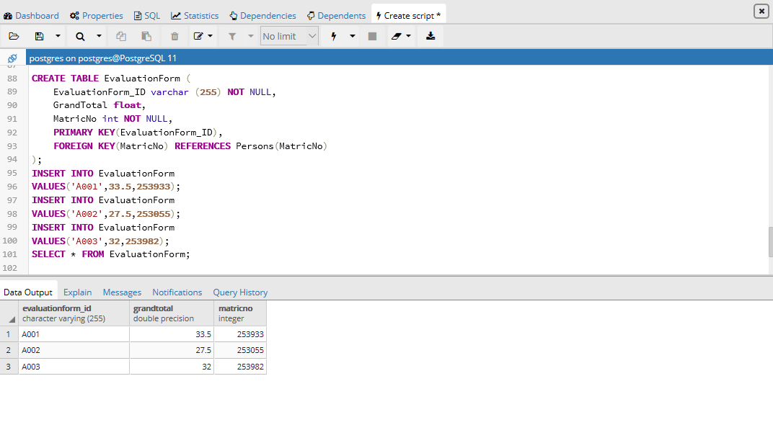

SELECT Persons.MatricNo,Persons.StudentName,Lecturer.LecturerName,

EvaluationForm.EvaluationForm_ID,SectionA.TotalA,SectionB.TotalB,SectionC.TotalC,EvaluationForm.GrandTotal

FROM Persons

INNER JOIN Lecturer ON Persons.MatricNo = Lecturer.MatricNo

INNER JOIN EvaluationForm ON Persons.MatricNo = EvaluationForm.MatricNo

INNER JOIN SectionA ON Persons.MatricNo = SectionA.MatricNo

INNER JOIN SectionB ON Persons.MatricNo = SectionB.MatricNo

INNER JOIN SectionC ON Persons.MatricNo = SectionC.MatricNo

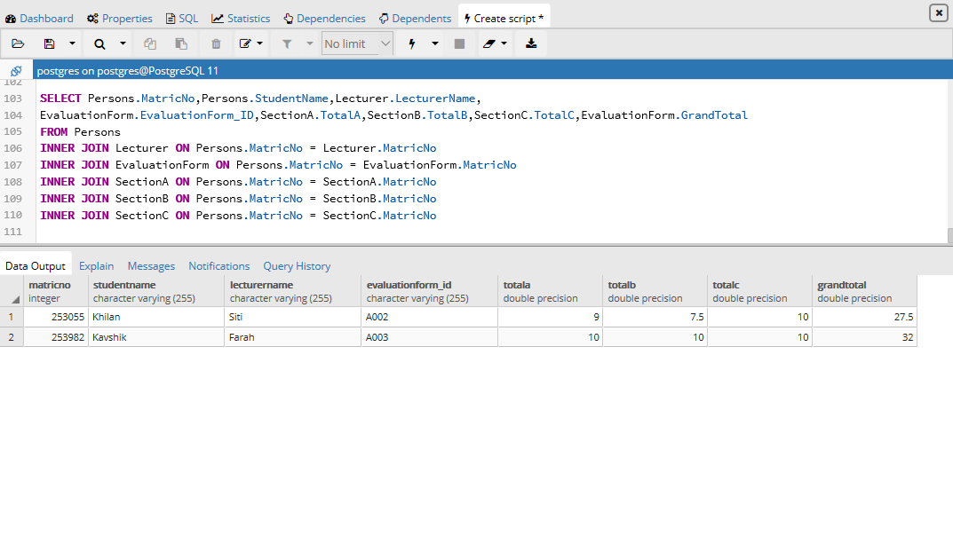

**SELECT**

package prak02;

import java.sql.Connection;

import java.sql.DriverManager;

import java.sql.ResultSet;

import java.sql.Statement;

public class PRAK02 {

public static void main( String args[] ) {

Connection c = null;

Statement stmt = null;

try {

Class.forName("org.postgresql.Driver");

c = DriverManager

.getConnection("jdbc:postgresql://localhost:5432/",

"postgres", "JieYee010052");

c.setAutoCommit(false);

System.out.println("Opened database successfully");

stmt = c.createStatement();

ResultSet rs = stmt.executeQuery( "SELECT * FROM Persons;" );

while ( rs.next() ) {

int MatricNo = rs.getInt("MatricNo");

String StudentName = rs.getString("StudentName");

int Semester = rs.getInt("Semester");

String Session = rs.getString("Session");

String Organization = rs.getString("Organization");

System.out.println( "MatricNo= " + MatricNo );

System.out.println( "StudentName = " + StudentName );

System.out.println( "Semester = " + Semester );

System.out.println( "Session = " + Session );

System.out.println( "Organization = " + Organization );

System.out.println();

}

rs.close();

stmt.close();

c.close();

} catch ( Exception e ) {

System.err.println( e.getClass().getName()+": "+ e.getMessage() );

System.exit(0);

}

System.out.println("Operation done successfully");

}

}

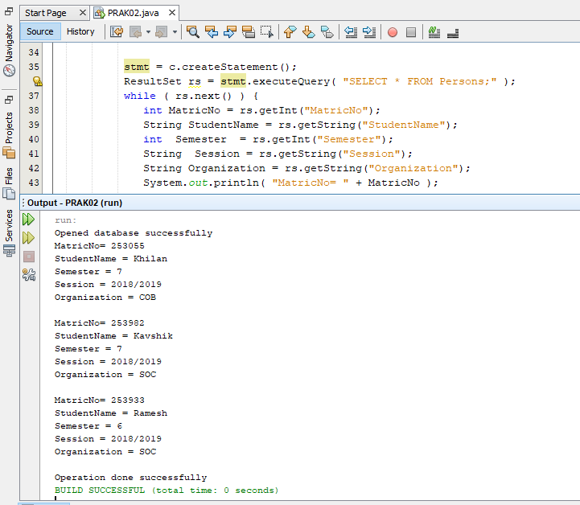

**UPDATE**

package prak02;

import java.sql.Connection;

import java.sql.DriverManager;

import java.sql.ResultSet;

import java.sql.Statement;

public class PRAK02 {

public static void main( String args[] ) {

Connection c = null;

Statement stmt = null;

try {

Class.forName("org.postgresql.Driver");

c = DriverManager

.getConnection("jdbc:postgresql://localhost:5432/",

"postgres", "JieYee010052");

c.setAutoCommit(false);

System.out.println("Opened database successfully");

stmt = c.createStatement();

String sql = "UPDATE Persons set Semester = 6 where MatricNo=253933;";

stmt.executeUpdate(sql);

c.commit();

ResultSet rs = stmt.executeQuery( "SELECT * FROM Persons;" );

while ( rs.next() ) {

int MatricNo = rs.getInt("MatricNo");

String StudentName = rs.getString("StudentName");

String Semester = rs.getString("Semester");

String Session = rs.getString("Session");

String Organization = rs.getString("Organization");

System.out.println( "MatricNo = " + MatricNo );

System.out.println( "StudentName = " + StudentName );

System.out.println( "Semester = " + Semester );

System.out.println( "Session = " + Session );

System.out.println( "Organization = " + Organization );

System.out.println();

}

rs.close();

stmt.close();

c.close();

} catch ( Exception e ) {

System.err.println( e.getClass().getName()+": "+ e.getMessage() );

System.exit(0);

}

System.out.println("Operation done successfully");

}

}

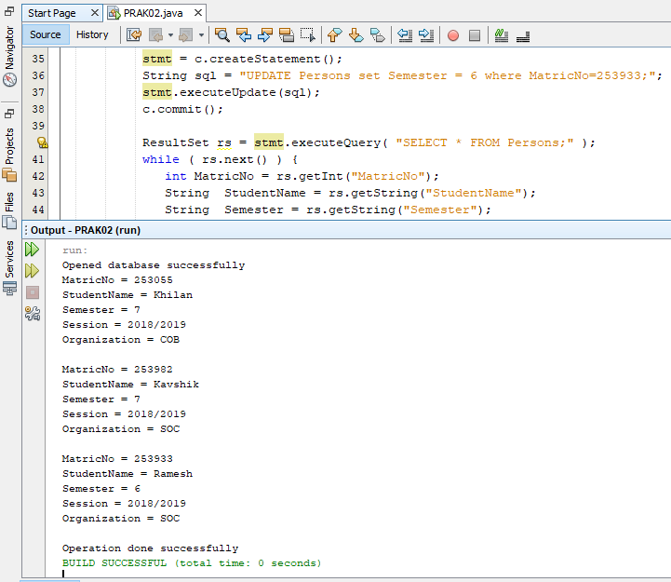

**DELETE**

package prak02;

import java.sql.Connection;

import java.sql.DriverManager;

import java.sql.ResultSet;

import java.sql.Statement;

public class PRAK02 {

public static void main( String args[] ) {

Connection c = null;

Statement stmt = null;

try {

Class.forName("org.postgresql.Driver");

c = DriverManager

.getConnection("jdbc:postgresql://localhost:5432/",

"postgres", "JieYee010052");

c.setAutoCommit(false);

System.out.println("Opened database successfully");

stmt = c.createStatement();

String sql = "DELETE from Lecturer where LecturerName = 'Selina';";

stmt.executeUpdate(sql);

c.commit();

ResultSet rs = stmt.executeQuery( "SELECT * FROM Lecturer;" );

while ( rs.next() ) {

String LecturerName = rs.getString("LecturerName");

String Date = rs.getString("Date");

int MatricNo = rs.getInt("MatricNo");

System.out.println( "LecturerName = " + LecturerName );

System.out.println( "Date = " + Date );

System.out.println( "MatricNo = " + MatricNo );

System.out.println();

}

rs.close();

stmt.close();

c.close();

} catch ( Exception e ) {

System.err.println( e.getClass().getName()+": "+ e.getMessage() );

System.exit(0);

}

System.out.println("Operation done successfully");

}

}

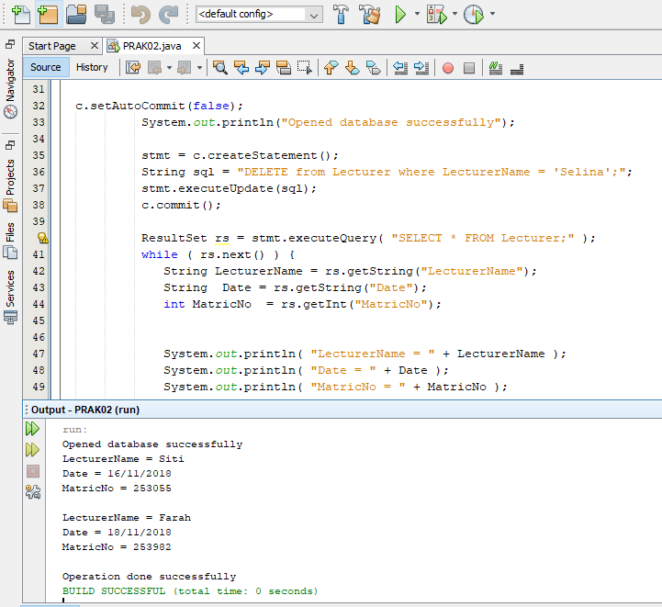

**WRITE**

package prak02;

import java.sql.Connection;

import java.sql.DriverManager;

import java.sql.ResultSet;

import java.sql.Statement;

public class PRAK02 {

public static void main( String args[] ) {

Connection c = null;

Statement stmt = null;

try {

Class.forName("org.postgresql.Driver");

c = DriverManager

.getConnection("jdbc:postgresql://localhost:5432/",

"postgres", "JieYee010052");

c.setAutoCommit(false);

System.out.println("Opened database successfully");

stmt = c.createStatement();

String sql = "INSERT INTO Persons (MatricNo, StudentName, Semester, Session, Organization)"

+ "VALUES ('253344', 'Ivy', 5, '2018/2019', 'COB');";

stmt.executeUpdate(sql);

c.commit();

stmt.close();

c.close();

} catch ( Exception e ) {

System.err.println( e.getClass().getName()+": "+ e.getMessage() );

System.exit(0);

}

System.out.println("Operation done successfully");

}

}

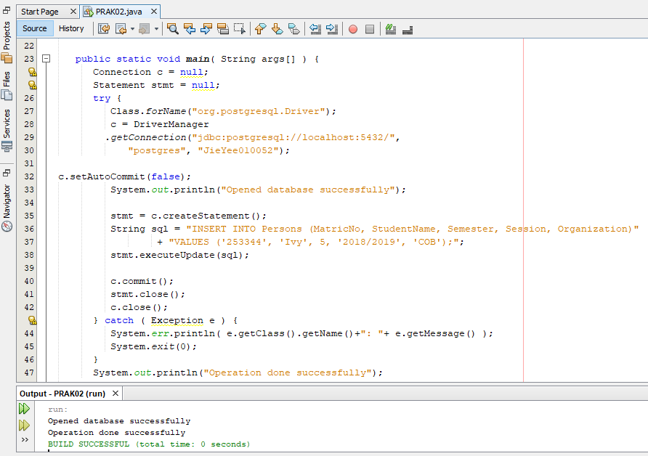

After Insert New Data

